**TIME MANAGEMENT APPLICATION**

**READ.ME FILE:**

Link for video: <https://youtu.be/nAp3PAVuW_0?si=f_UKXUNIlg72Ga7h>

**Introduction:**

The program is a simple WPF (Windows Presentation Foundation) that consists of a registration process and login system. Upon logging in, users may log in their study hours, control, and track their study modules, and obtain information regarding their self-study hours. This README file provides an overview of the code structure and how to use the application.

**Requirements:**

* For the development version of the.NET Framework
* Microsoft SQL Server that supports LocalDB
* The database file (registerDB.mdf) at the path indicated or a connection string update.

Features:

Registration (reg.xaml)

Users can: Input their first and last names, password, and username when registering.

Obtain confirmation feedback for existing usernames, mismatched passwords, and insufficient data.

Log in using (Login.xaml)

Users can: Enter their password and username to log in.

Receive validation feedback for inaccurate credentials and inadequate data.

Main Window (MainWindow.xaml): This allows users to:

Users can: modules with names, codes, credits, and weekly class hours.

Keep track of your study hours for various modules on specified days.

Specify the semester's start date and number of weeks.

See the modules' estimated hours of self-study listed.

From the list, pick and view the information of a certain module.

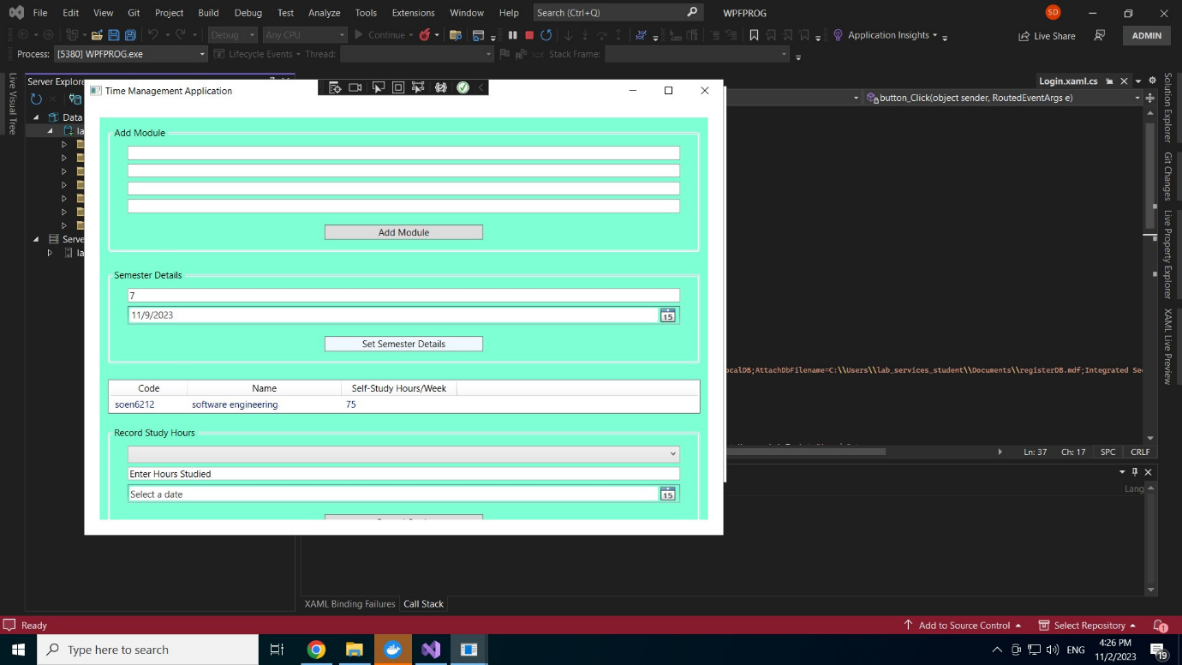

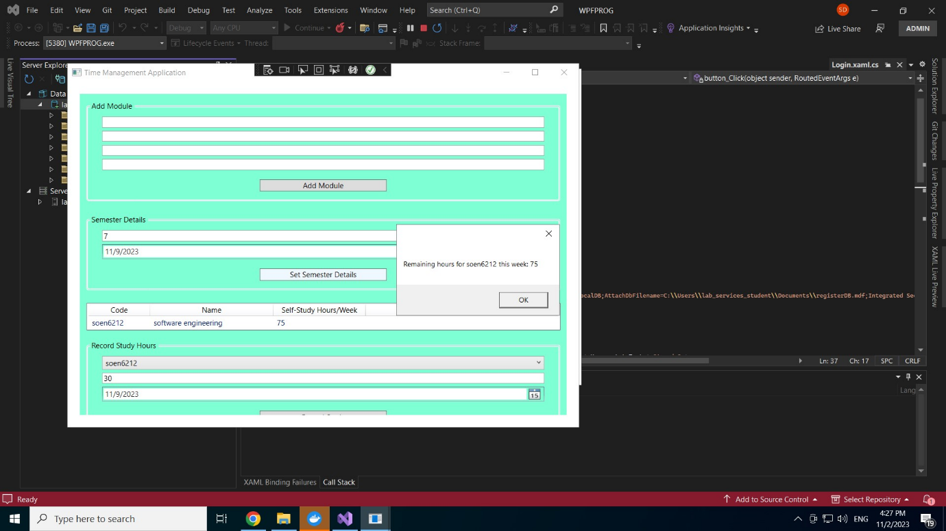

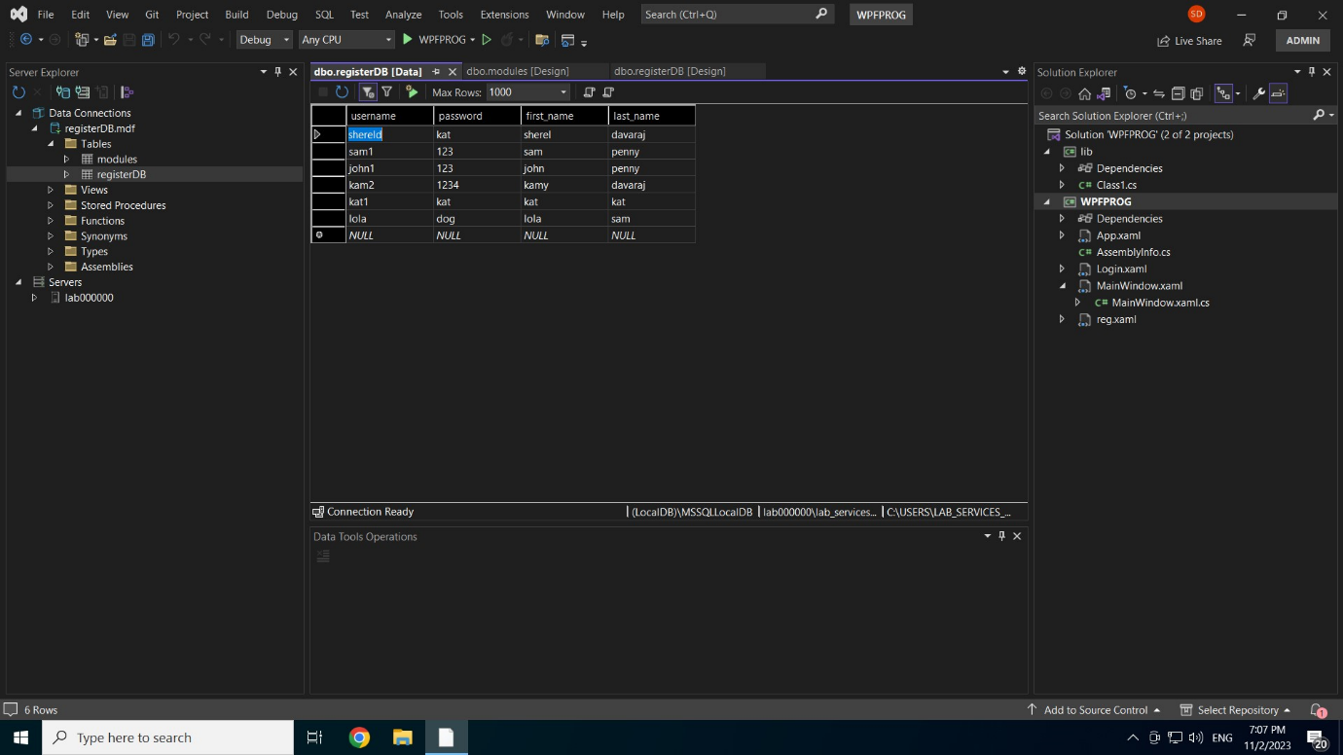Data being stored :

How to run the program:

* The connection string in both the reg.xaml.cs and Login.xaml.cs files or attach the supplied registerDB.mdf file.
* Launch the application in   Visual Studio.
* If you're a first-time user, go to the registration page and complete the required details.
* To access the main application if you are an already-registered user, go to the login page and input the details on the login page.

Utilizing the Primary Program

* By specifying the module's specifics, you can add new study modules.

For each module, note how many hours you spent studying.

Define the start and end dates of the semester.